The first law of defensive programming:

When you have to defend, You have already lost هنگامی که شما باید دفاع کنید، قبلا از دست داده اید

* **Consistent objects**
  + Create consistent and complete objects ایجاد اشیاء سازگار و کامل
* Consistent mutations
  + All transitions must lead to complete and consistent state تمام گذرها باید به حالت کامل و سازگار منجر شوند
* **No primitive types**
  + Avoid excessive use of primitive types اجتناب از استفاده بیش از حد از انواع ابتدایی
  + Replace primitive types with custom domain types
  + Consequence : no defense
* **Function domains**
  + Satisfy mandatory conditions before making a function call رعایت شروط اجباری قبل از اجرای توابع

Try{

doSomethings();

}catch(InvalidOperationException){ 🡨 **Defensive code**

…

}

* Defensive design starts after this point
* **Defensive design**
  + Encapsulate state and operations
  + Unify positive and negative execution flows متحد کردن جریان های مثبت و منفی اجرا
* **Objects, not nulls**
  + Do not use null references
  + Without null : no defense
* **Rich domain models**
  + Immutability: Good servant, bad master تغییر ناپذیری : کلاینت خوب ، سرور بد
  + Restricted mutability for the best of both worlds تغییر پذیری محدود برای هر دو جهان
  + Historical modeling for powerful features
* **No exceptions**
  + Do not introduce alternate execution paths with exceptions
  + Do not use exceptions as just another heavyweight if-else
  + Better approach : pass either the result or the error in a discriminated union رویکرد بهتر: نتیجه یا خطای یک یونیون تبعیض آمیز را منتقل کنید

**Defensive code is a matter of choice**

**Cheap features: defined in code**

**Expensive features: defined in design**

**Traditional defensive techniques**

|  |  |
| --- | --- |
| Predictability پیش بینی پذیری | Reveal intention افشای قصد   * Method name * Argument name * Return value |
| **Certainty** یقین | Do not pass switches to a method   * No Boolean arguments * No enum arguments   Switches introduce uncertainty  Method should do one thing with absolute certainty متد باید یک چیز را با اطمینان مطلق انجام دهد |
| **Simplicity** سادگی | * Keep small number of method arguments * Keep the code short * Avoid branching when possible * Avoid code repetition |
| **Completeness** تکمیل | * **If** instruction should have a reasonable **else** branch * **Switch** instruction should have a reasonable **default** case |
| **Failing fast** شکست سریع | Do not let bad data propagate اجازه ندهید اطلاعات بد منتشر شود |
| **Handling errors** رسیدگی به خطاها | * Handle errors when day happen * Assert preconditions, postconditions and invariants * Add global exception handler to keep the application running |

**An experiment**

bool Contains(int[] arr, int srch)

{

for (int i = 0 ; i< arr.length(); i++)

{

if(arr[i] == srch)

{

return true;

}

}

return false;

}

-🡪

bool Contains(int[] arr, int srch)

{

Int end = ar.length-1;

Int last = ar[end];

Arr[end] = srch;

Int index = 0;

While(ar[index] != search)

{

Index = index +1;

}

Ar[end] = last;

Return index < end || last == srch;

}

Proactive caller: if(valid(x)) obj.Dosomethings(x);

Reactive caller : try{

obj.Dosomethings(x);

}catch…

Want to avoid error conditions

Produce design in which they can’t appear

**Software which repeatedly transforms one system state into the next system state**

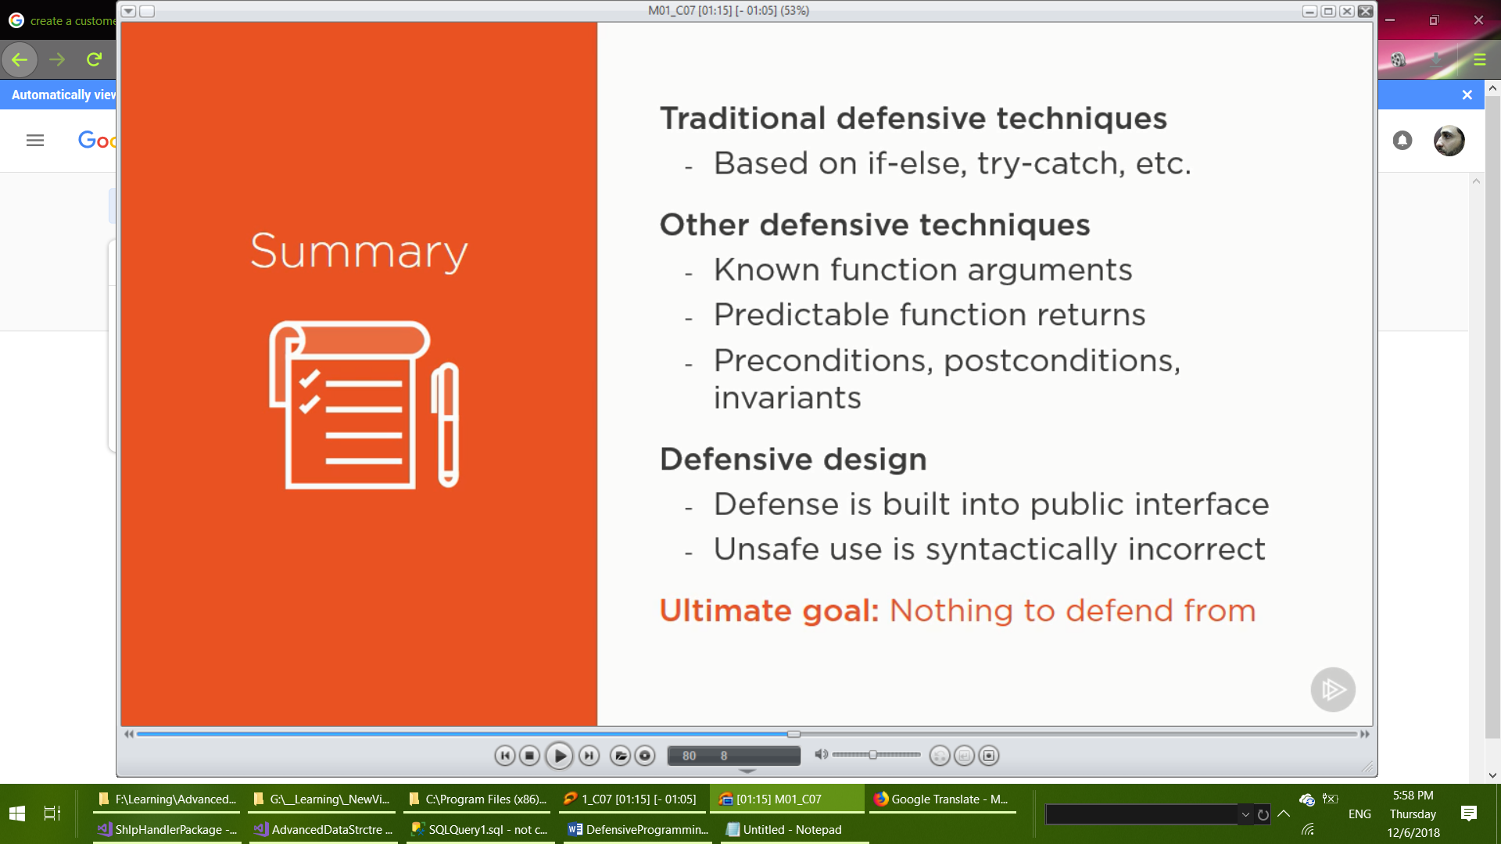

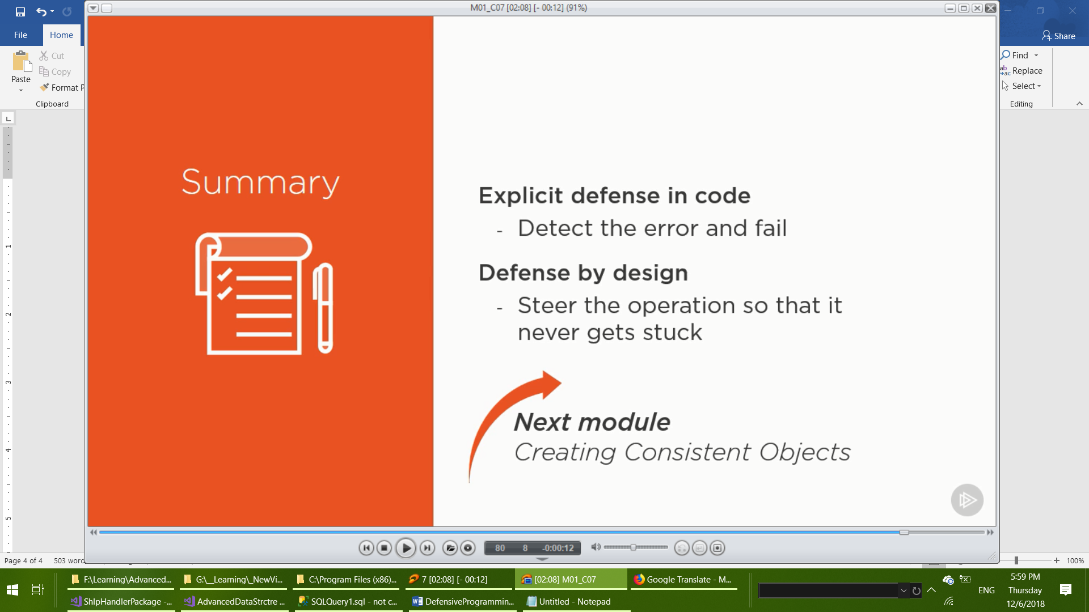

Implicit parameter less constructor is the built-in factory function

Set numeric fields to zero, Boolean to false, references to null

In customized constructor: when invalid data are received new object must **not** constructed.

Constructor must ensure that only valid objects can be created.

The customized constructor caller will never be able to obtain an inconsistent object.

Provide your own factory function for every stateful objects.

**Rules of thumb:**

Define one factory function per class

Have no discrete parameters (no enum , Boolean , etc.)

**Return the build method instead of executing it!!!**

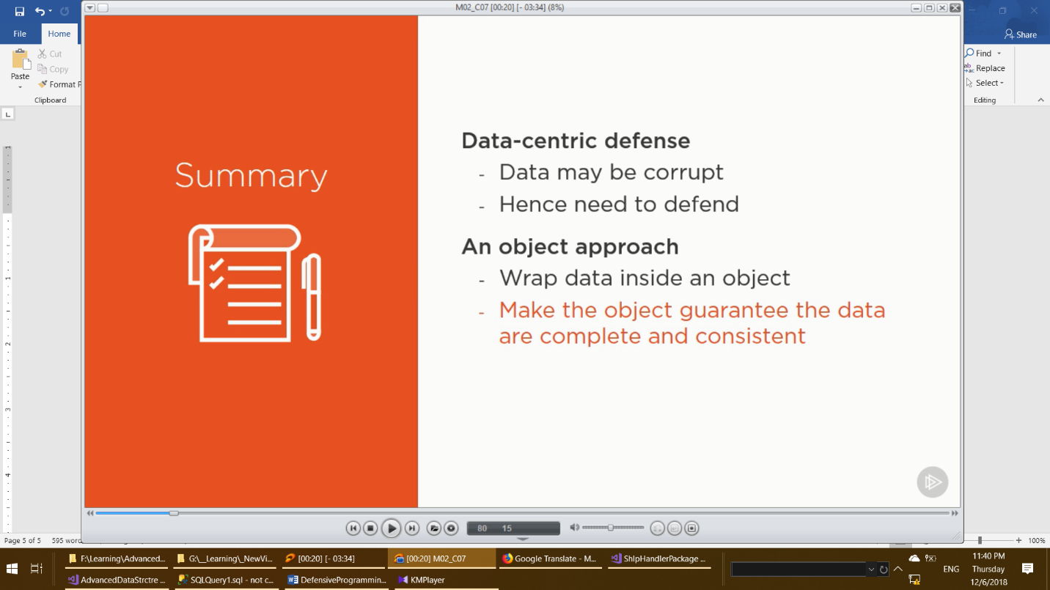

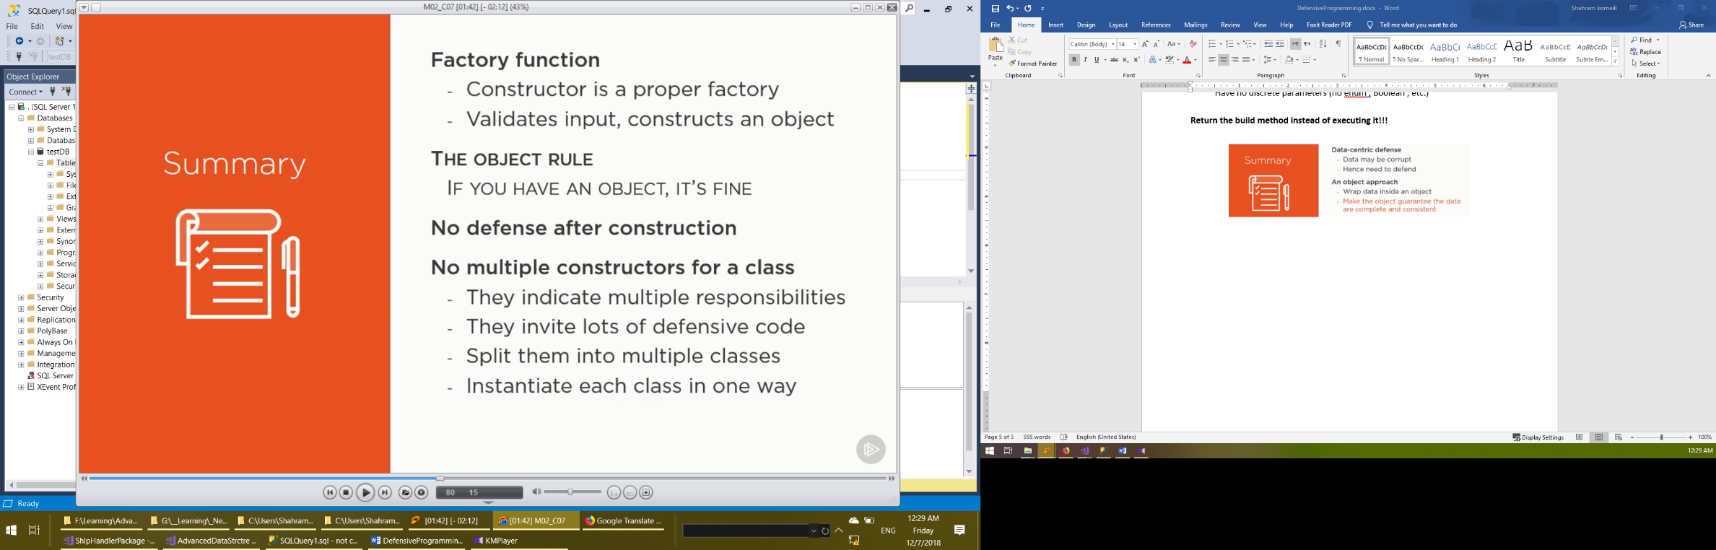

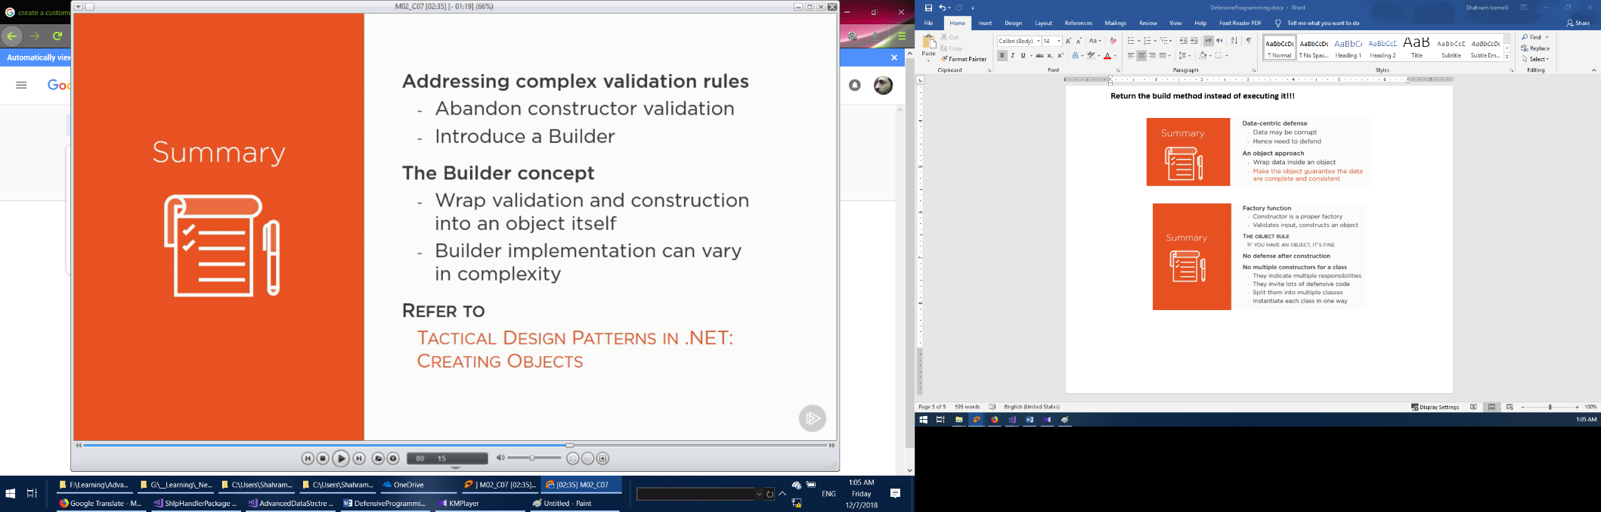



**For complex construction validation:**

1. Lightweight solution
   1. Use constructor as a factory function
2. Middle solution
   1. Series of small factory function
3. heavyweight solution
   1. use builder for complex validation

**Domain Model:**

1. Default constructor:
   1. Include parameter less constructor in all model classes
   2. Constructor can be private (ORM will access it via reflection)
2. Property setters:
   1. Setters on all properties defining persist able state
   2. Setters can be private (ORM will access them via reflection)
3. No setter validation:
   1. Property setters must be dumb(بی عقل)
   2. ORM is not aware(مطلع) of any setter rules
   3. Object materialization(تحقق) may fail if setters can throw
4. Database ID field:
   1. Include database identity in every model class

**Separate persistence model:**

1. New model:
   1. Define new model in the infrastructure layer
   2. No constructor rules
   3. No validation
2. Plain getters/setters:
   1. Plain property getters and setters
   2. Setters with no validation
   3. Not same as the domain model
   4. Designed to support fast and easy persistence
3. Two-way mapping:
   1. There must be a mapping between domain model and persistence model
   2. Map new domain object before persisting it
   3. Map persisted object to domain object before using it

|  |  |
| --- | --- |
| How to decide | |
| Simple model | Complex model |
| Make the domain model persistable | invest in separating persistence from domain |
| That saves a lot of work | Hard to add persistence to an already complex domain model |
|  | That would add unwanted complexity |
|  | Persistence tradeoffs are not welcome in complex domains |

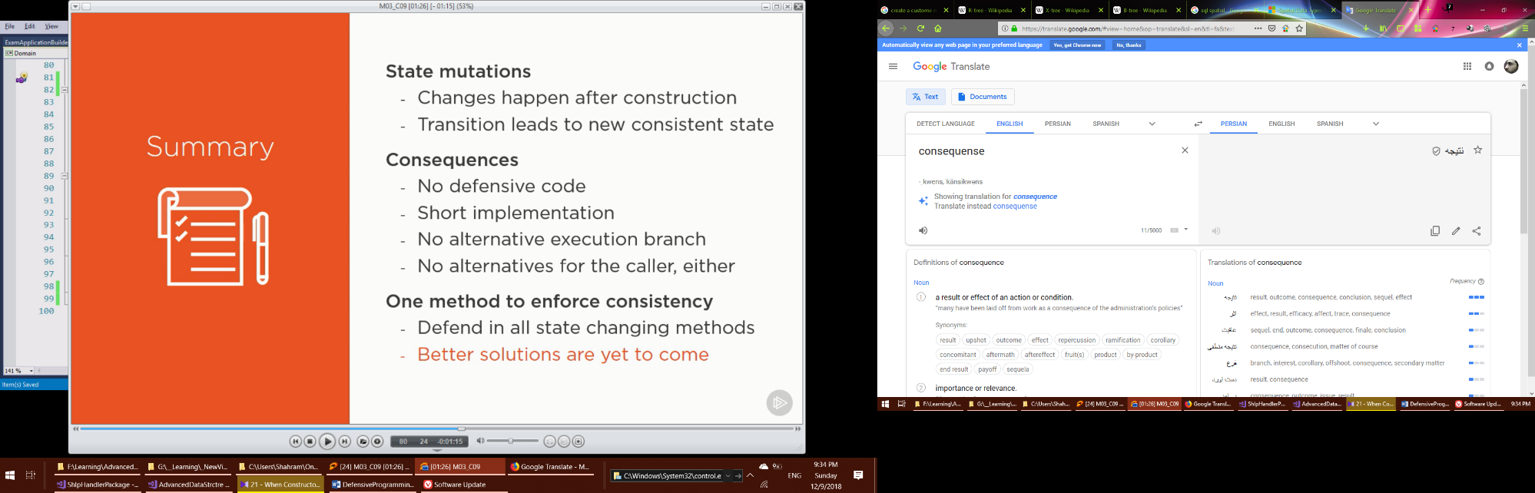

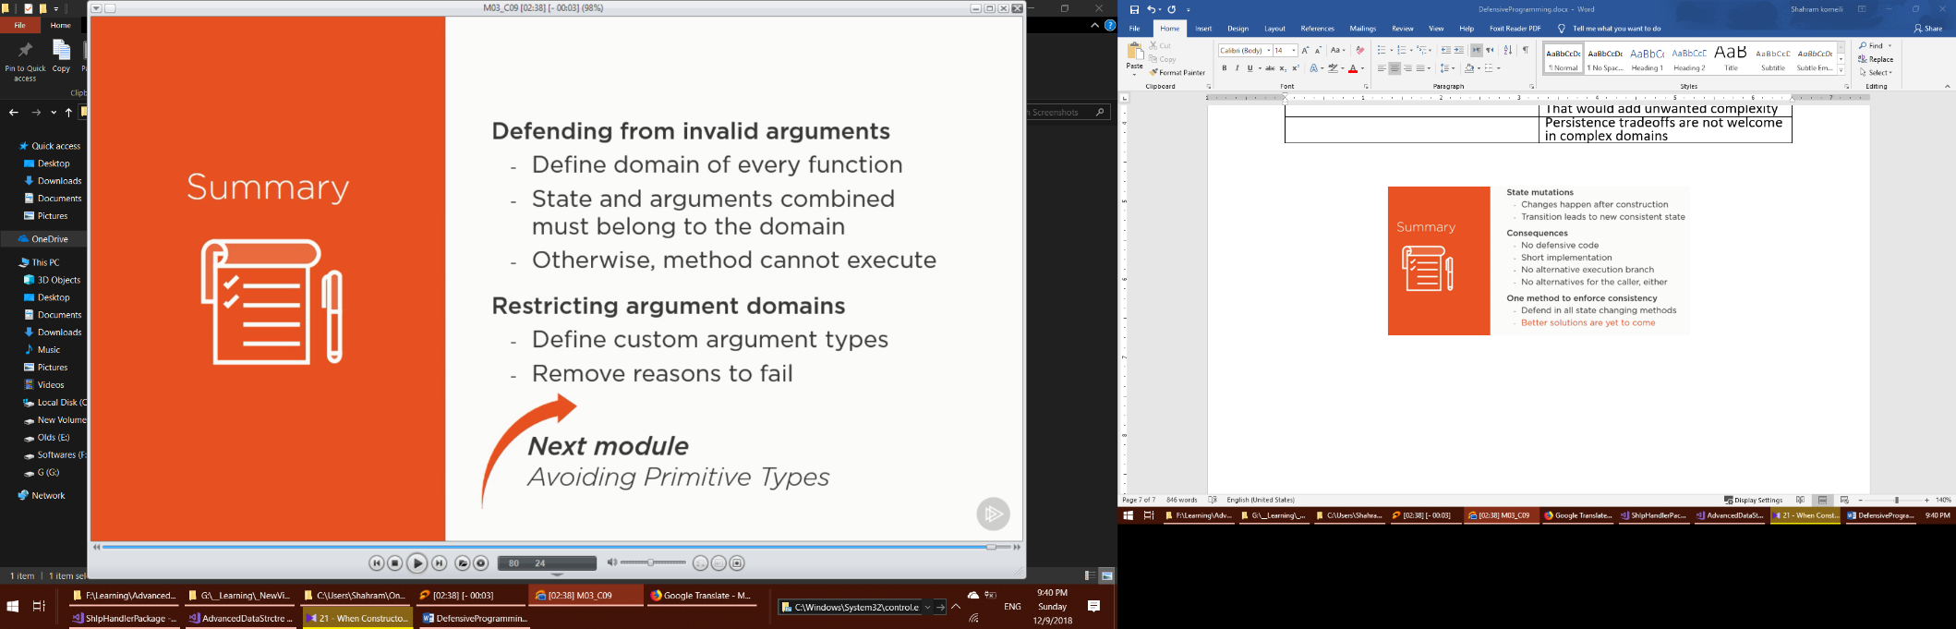

|  |  |
| --- | --- |
| Coding with enumerations | |
| Practical effects | Also know as |
| Assignment must be guarded | No type safety |
| Change affects users | No polymorphism |
| Guarding requires alternative implementation | Design flaws |
| Enumeration produces no objects | Violation of object-oriented concepts |

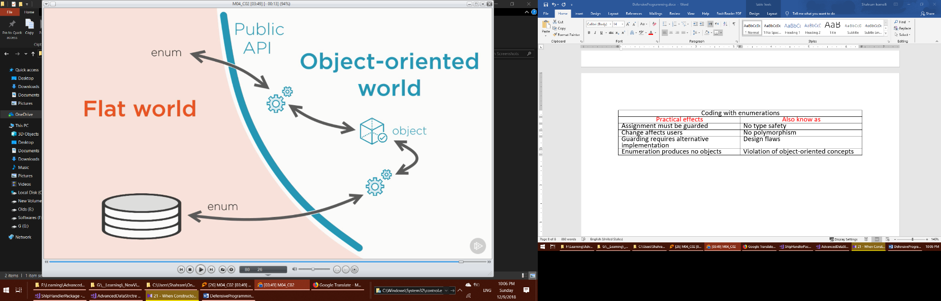

The Stringification trap

Turning objects into strings = stringification

To send over network, save to database, etc.

Then, why string inside domain objects?

**Use Class instead of Enum , Use class instead of String**

**USE CLASS INSTEAD OF ALLLLLL.**

**pitfalls of primitive’s types**

Encapsulate primitive types in a class

Do not accept primitive type arguments

**Command-query segregation principle (CQRS)**

Principle: Keep commands separate from queries.

|  |  |
| --- | --- |
| **Command** | **Query** |
| Modifies the system state | Keeps the system state intact (only asks what the state is) |
| Applies all the rules | Loading lots of data |
| Performs all the validation | Expects to get the results fast (e.g populating a grid) |
| **Heavy, Complex, Expensive** | No rule checking (that was already done, wasn’ t it?) |

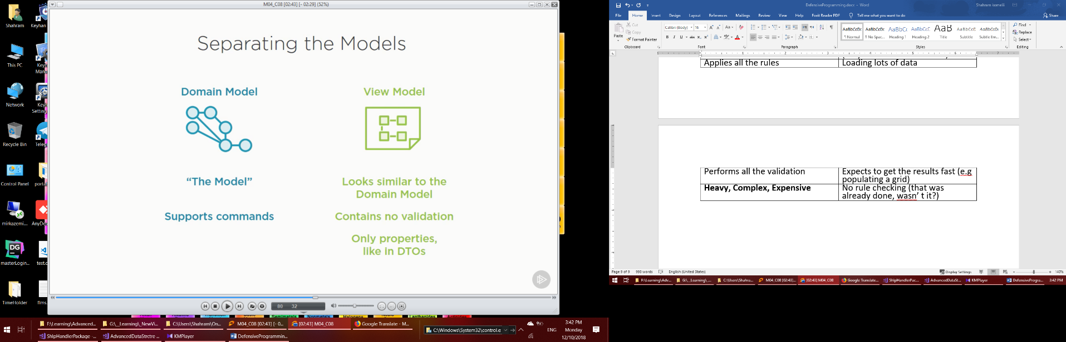

|  |  |
| --- | --- |
| **Data transfer object (DTO)** | **View Model** |
| Enables transfer over a flat channel | Meant to be rendered on the view |
| Public property getters for serialization | Public property getters to populated the view |
| Parameter less constructor | Parameter less constructor |
| Public property setters for deserialization | Public property setters for fast materialization |

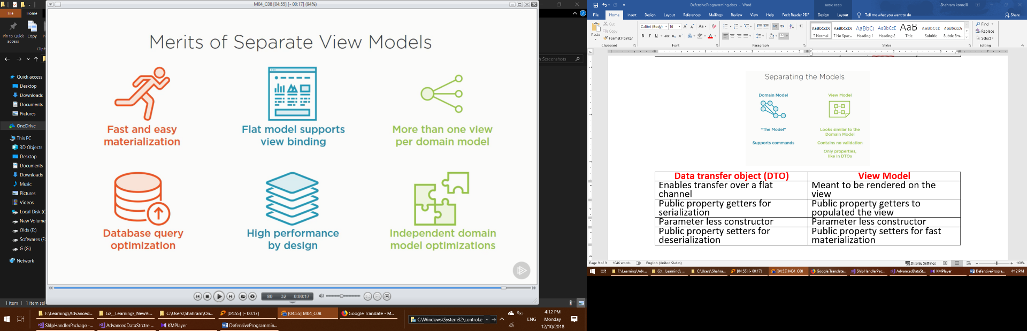

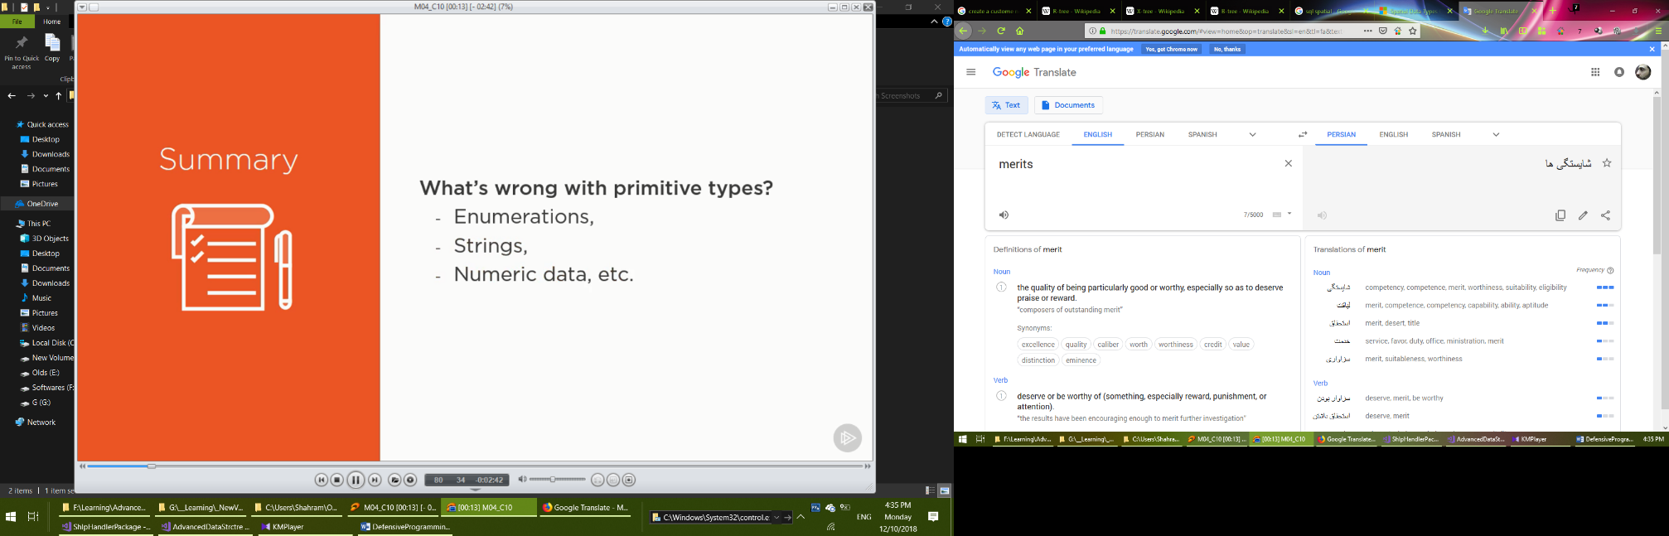

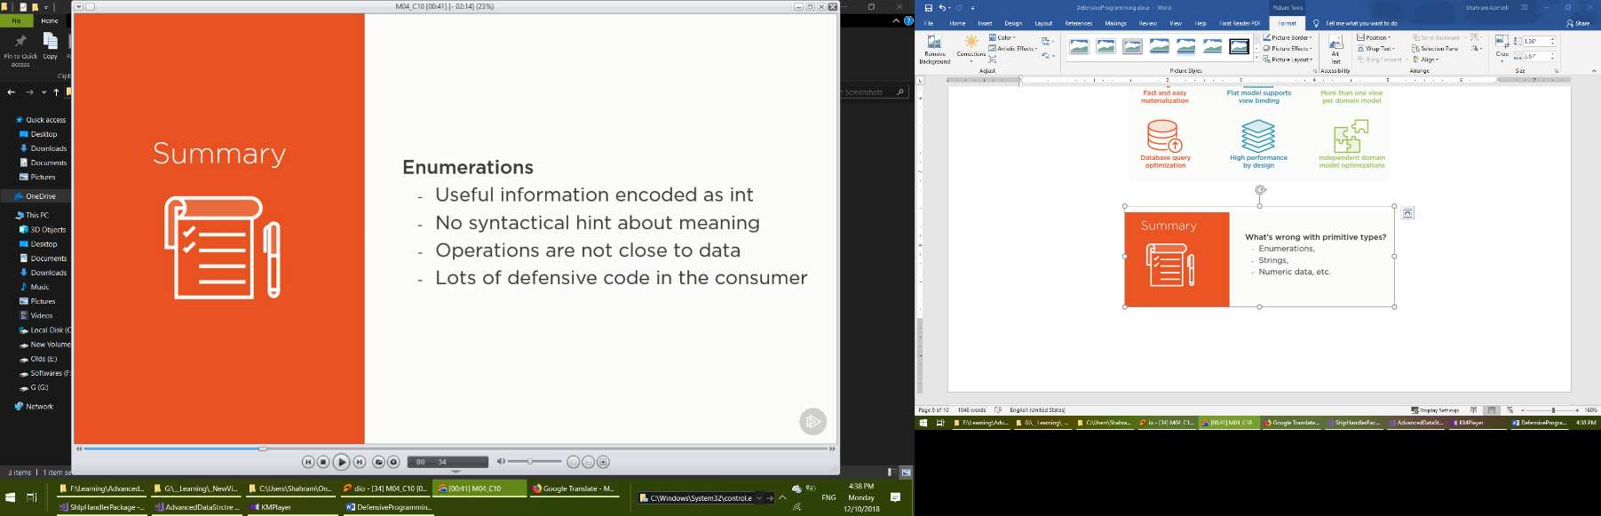

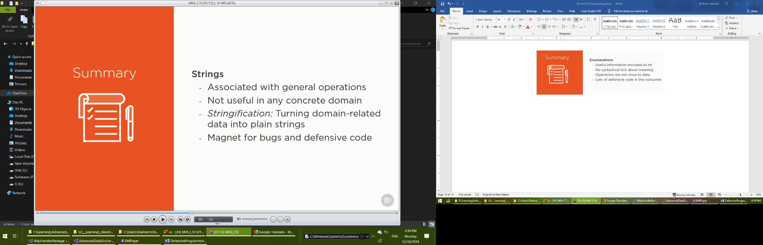

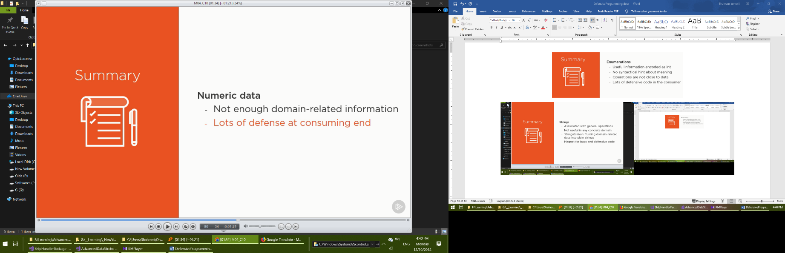

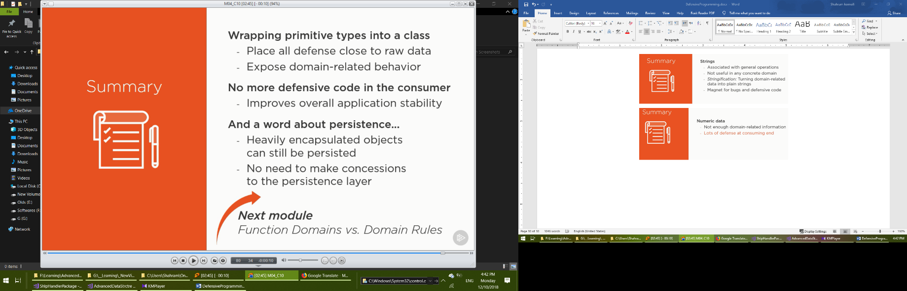

**Partial function:**

Function which is defined on a subset of all possible argument values.

**Total function:**

Function which is defined for all possible argument values.

**All Kinds of Guards**

* Null input
* Zero value
* Negative Value
* Empty string
* Whitespace string
* Incompatible values
* Violated rules

**Comparing guards:**

Domain Rules vs Algebra rules

Domain Rules Must be dynamic or configurable

**Input validation attributes:**

* Not null
* Not empty
* Required
* Credit card
* Email address
* Phone
* Regular expression
* String length
* Enum data type
* Greater than
* Less than
* Positive
* Strictly positive
* range
* Do not pass null as argument
* Do not return null from a method
* Do not set variables to null

**Building defensive design instead of writing defensive code**

Good encapsulate 🡪 not many things to defend from

Poor encapsulation 🡪 Lots of defensive code everywhere around

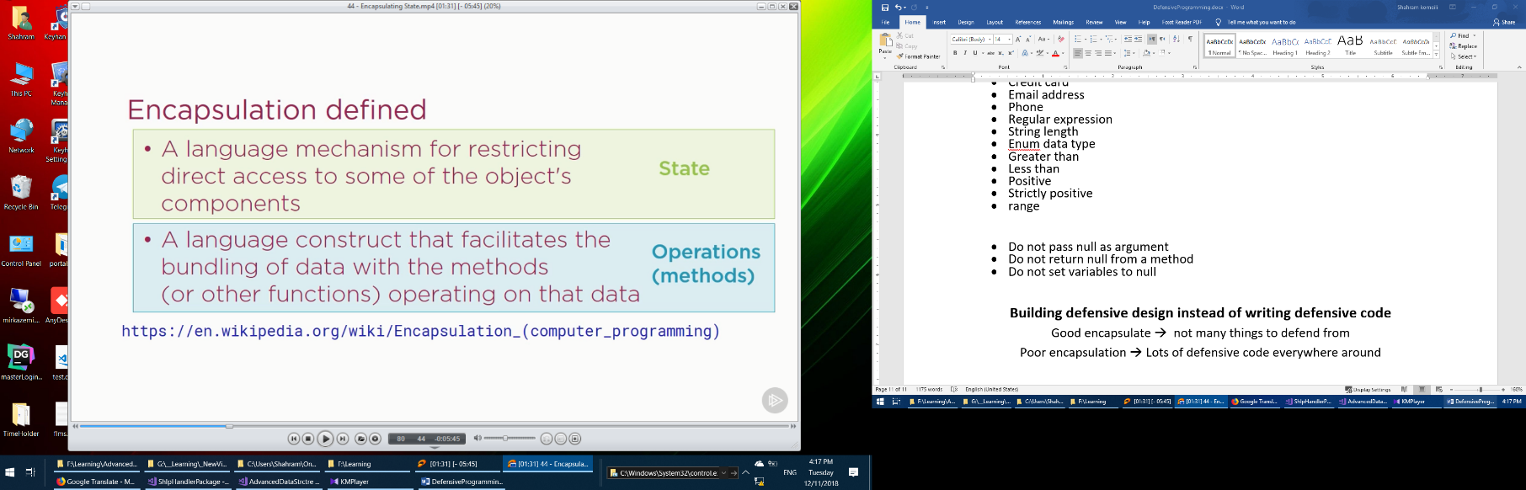

Encapsulation defined

A language mechanism for restricting direct access to some of the object’s components.

**Encapsulation state vs encapsulation behavior**

Advice class with low cohesion should be split into two

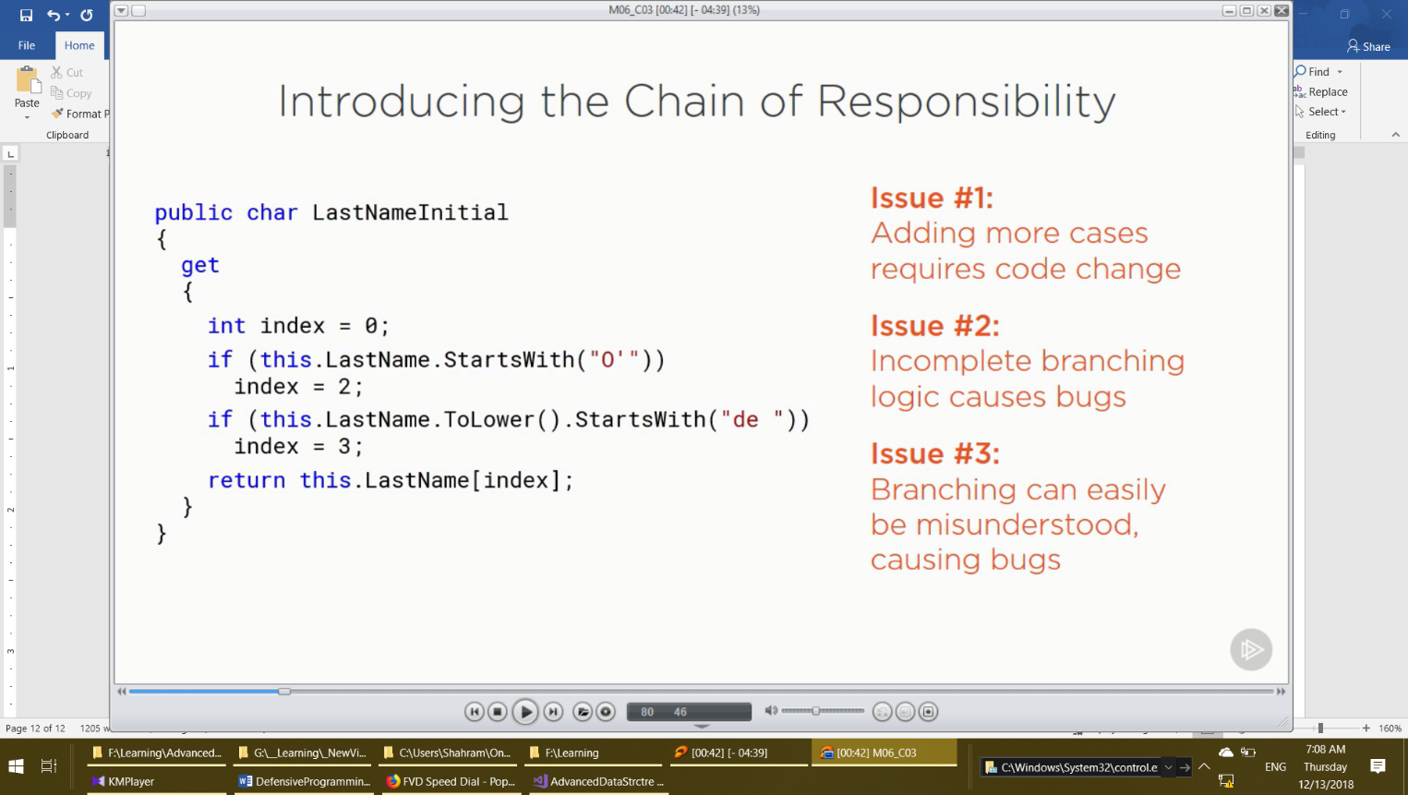

[**www.regex101.com**](http://www.regex101.com)for test reg ex patterns

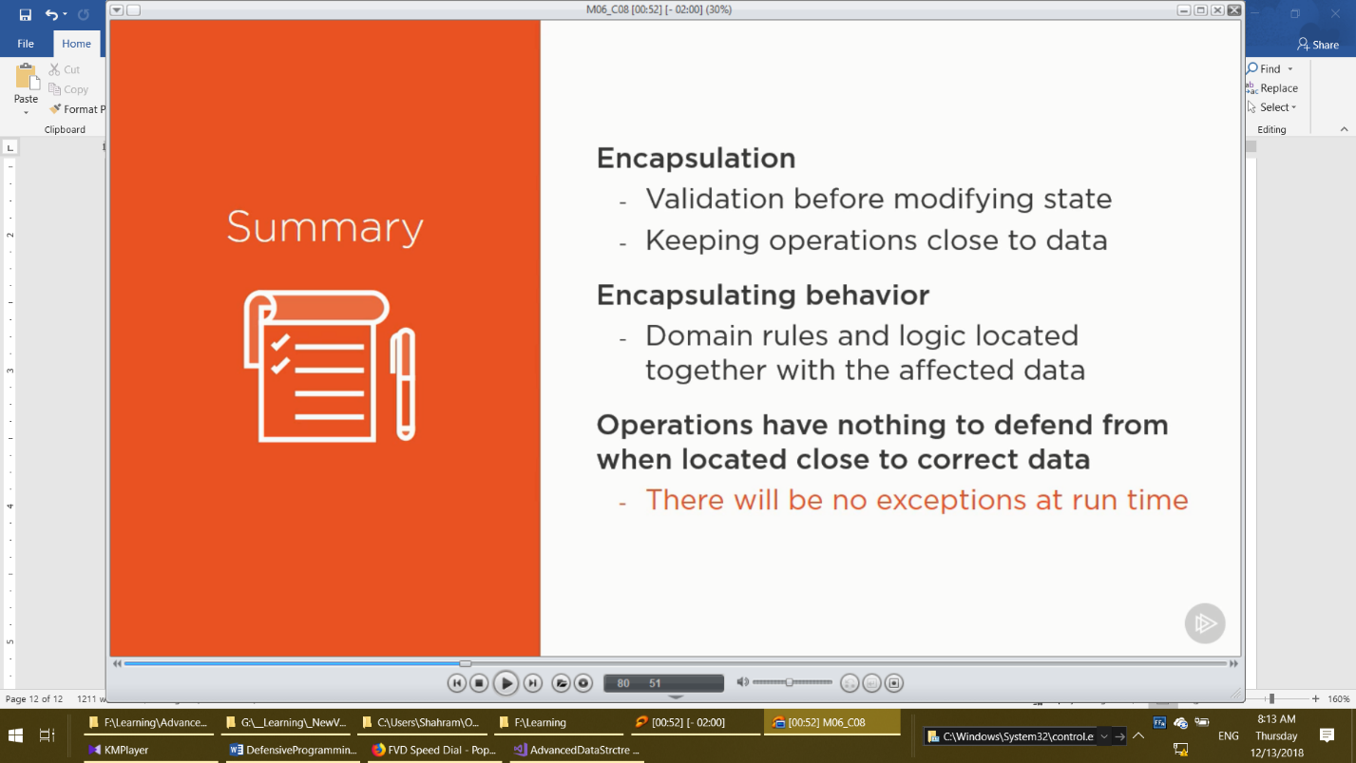

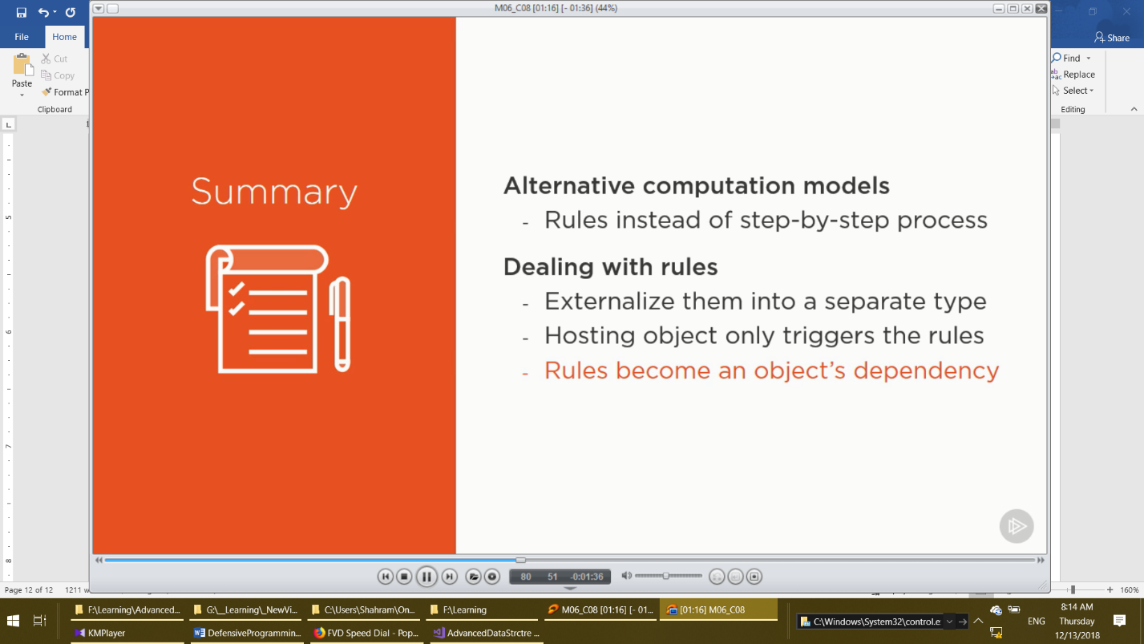

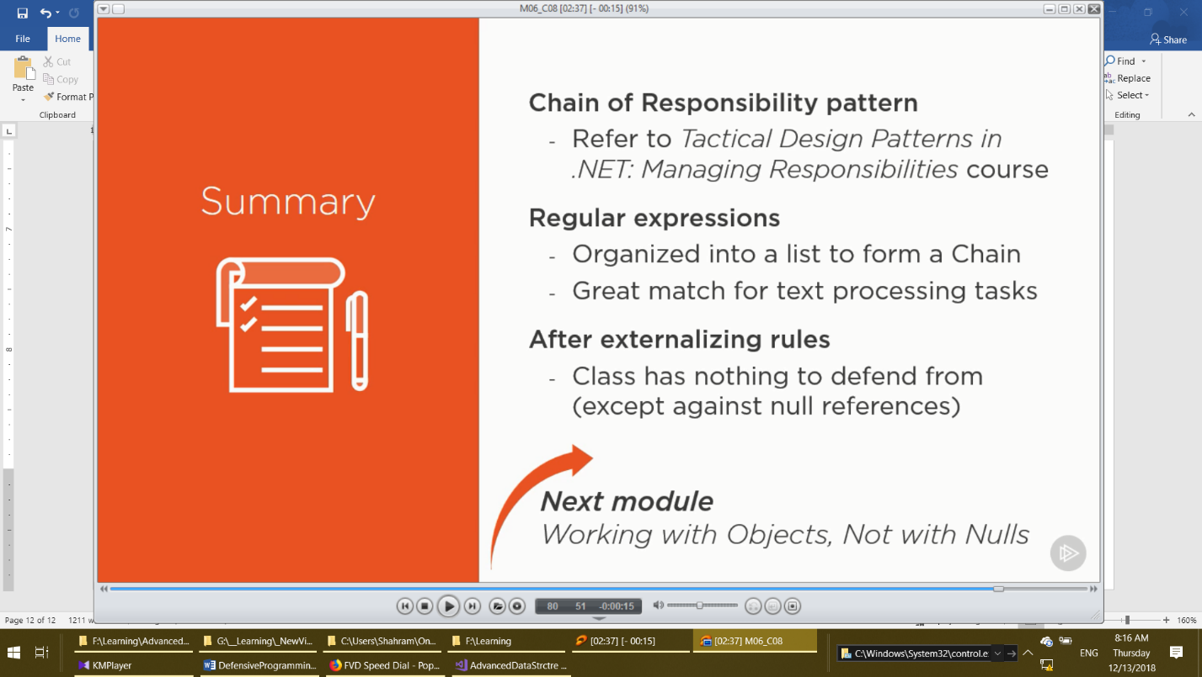

Application is well -tested when there are no more *NullRefrenceExceptions.*

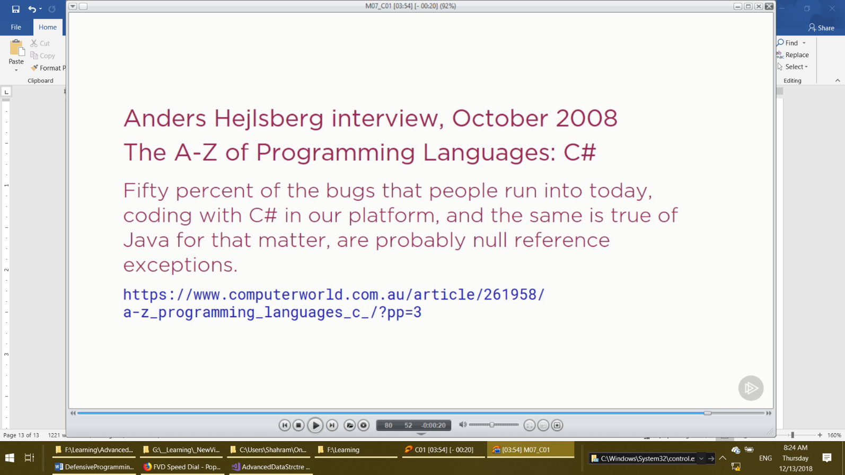

[**https://martinfowler.com/bliki/AliasingBug.html**](https://martinfowler.com/bliki/AliasingBug.html)

the problem: an object modifies a shared reference without telling the other object

what can we do? Reapplying validation imposes great increase in code complexity

<https://martinfowler.com/eaaDev/EventSourcing.html>

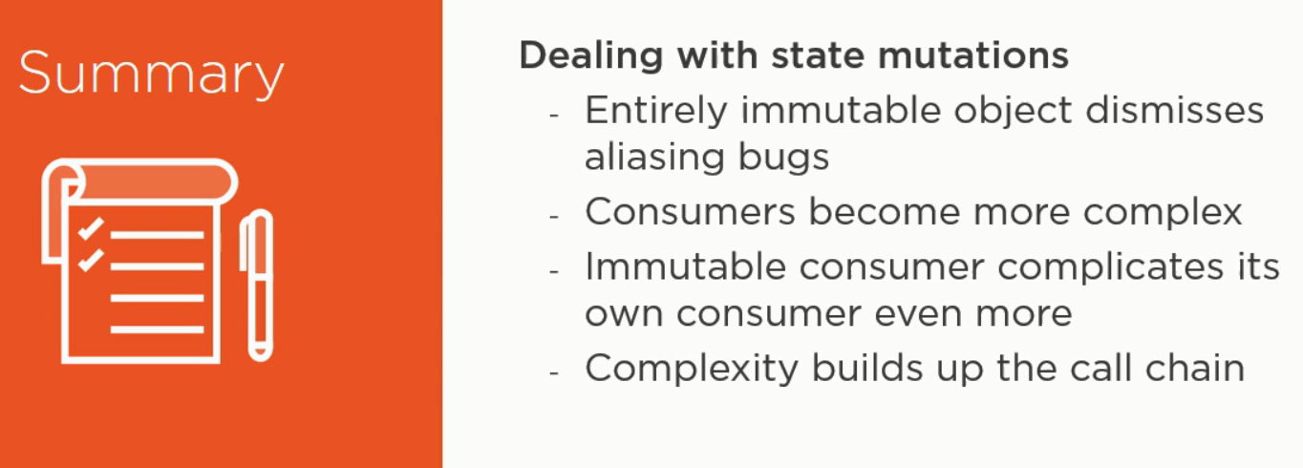

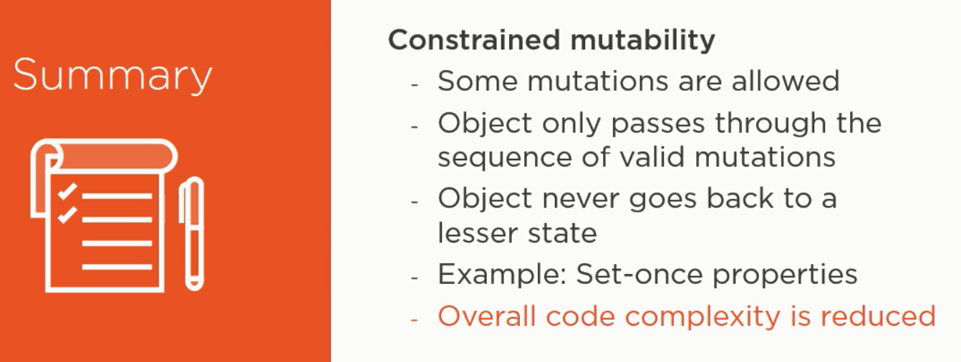

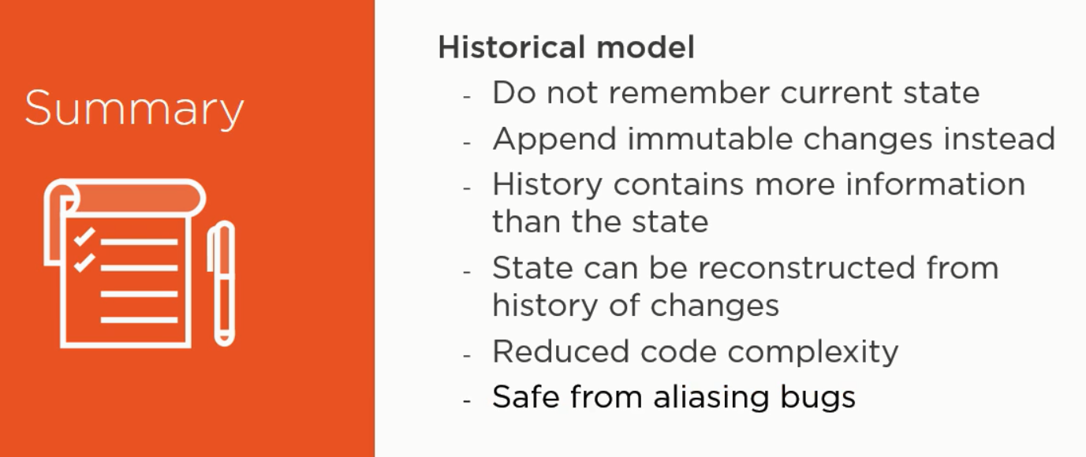

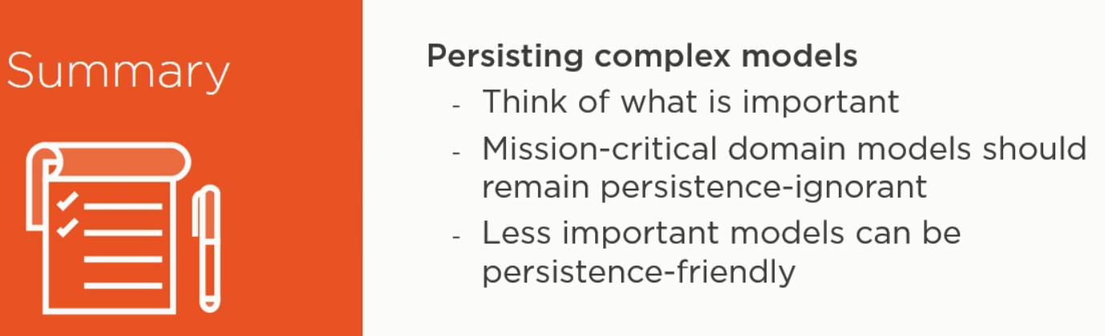

**Designing alternative workflows instead of defending from errors**

Don’t just log the exception. Code which handles it will log it anyway (supposedly).

Logging method arguments sometimes make sense.

Inability to recreate system state is indicative of an architectural flaw.

Don’t let out exceptions which are giving out your implementation details.

The caller could tightly couple to a concrete implementation.

**Advice on oo design:**

Handling implementation-specific exceptions lets you change implementation later without affecting consumers.

**Murphy’s law:**

Any thing guarded by a Boolean flag alone will sooner or later be accessed before it’s been initialized.



